PROJECT TITLE

21CSA697A

Final Report
Submitted by

Divya B Krishna

(AA.SC.P2MCA25010047)
in partial fulfilment of the requirements for the award of the degree of
MASTER OF COMPUTER APPLICATIONS



July 2026

Acknowledgement

I express my sincere gratitude to the Department of Computer Applications and my project guide for their valuable guidance and support throughout this project. I also thank the faculty members and my institution for providing the resources required to complete this work successfully. Finally, I thank my family and friends for their encouragement and support during the project.

Abstract

Retail businesses generate large volumes of transactional data that can be analyzed to improve decision-making and business performance. This project, titled "Retail Store Sales Analysis and Sales Prediction Using Machine Learning," focuses on developing an interactive web application to analyze retail sales data and generate meaningful business insights.
The Superstore Sales Dataset, containing 9,994 records and 21 attributes, was used for the study. The application was developed using Python and Streamlit, while Pandas, NumPy, Matplotlib, Seaborn, and Scikit-Learn were used for data preprocessing, visualization, and machine learning implementation. The dashboard allows users to upload a retail sales dataset, explore data summaries, visualize sales trends, and perform sales prediction through a user-friendly interface.
Exploratory Data Analysis (EDA) was performed to analyze sales distribution, category-wise performance, state-wise profitability, discount impact, yearly and monthly sales trends, and correlations among business variables. The analysis revealed that the Technology category generated the highest sales and profit, while Texas recorded the highest overall loss. A negative relationship between discount and profit was also identified.
A Linear Regression model was developed to predict sales using Quantity and Discount as input features. The model achieved an R² score of 0.0363, indicating that additional business variables are required for more accurate sales prediction. Overall, the project demonstrates how Data Science, Machine Learning, and interactive dashboard development can be integrated to support retail business analysis and decision-making.

List of Figures
Figure 1: Retail Sales Dashboard – Home Page
Figure 2: Dataset Preview
Figure 3: Dataset Summary
Figure 4: Sales Distribution Histogram
Figure 5: Category-wise Sales Bar Chart
Figure 6: Top 10 States by Sales
Figure 7: Monthly Sales Trend
Figure 8: Correlation Heatmap
Figure 9: Sales Prediction (Actual vs Predicted Values)
Figure 10: Model Accuracy (R² Score)
Figure 11: Actual vs Predicted Sales Scatter Plot
Figure 12: Key Insights Dashboard

List of Tables
Table 1: Dataset Summary – Total records, total columns, average sales, and average profit.
Table 2: Dataset Preview – Sample records from the uploaded Superstore dataset.
Table 3: Data Types and Missing Values – Summary of dataset structure and missing values.
Table 4: Category-wise Sales – Total sales generated by each product category.
Table 5: Top 10 States by Sales – States with the highest total sales.
Table 6: Monthly Sales Summary – Total sales recorded for each month.
Table 7: Correlation Matrix – Correlation values among Sales, Quantity, Discount, and Profit.
Table 8: Actual vs Predicted Sales – Comparison of actual and predicted sales values.
Table 9: Model Performance Evaluation – R² score of the Linear Regression model.
Table 10: Key Insights – Summary of major findings from the analysis.

List of Abbreviations
AI – Artificial Intelligence
CSV – Comma Separated Values
DF – DataFrame
EDA – Exploratory Data Analysis
Jupyter Notebook – Interactive Python Development Environment
KPI – Key Performance Indicator
ML – Machine Learning
NumPy – Numerical Python Library
Pandas – Python Data Analysis Library
R² – Coefficient of Determination
Scikit-Learn – Machine Learning Library for Python
VS Code – Visual Studio Code
Streamlit – Python Framework for Building Interactive Web Applications

Chapter 1
- Introduction
Retail businesses generate large volumes of sales data every day through customer transactions, product purchases, inventory movements, and promotional activities. Analyzing this data can help organizations understand customer behavior, identify profitable products, optimize pricing strategies, and improve overall business performance. With the growth of data-driven decision making, Data Science techniques have become essential tools for extracting valuable insights from large datasets.
Retail sales analysis plays an important role in helping organizations monitor business performance and identify trends that influence revenue and profitability. Through proper analysis of historical sales data, businesses can discover seasonal patterns, understand regional performance differences, and evaluate the impact of discounts and promotional campaigns. Such insights support informed business decisions and improve operational efficiency.
Machine Learning techniques further enhance retail analytics by enabling predictive analysis. Sales prediction helps businesses estimate future demand, plan inventory levels, and develop effective marketing strategies. Although advanced forecasting models are available, simple regression techniques can also provide useful insights into relationships between sales and influencing factors.
This project focuses on the analysis of retail store sales data using Data Science techniques and a basic Machine Learning model. The study uses the Superstore Sales Dataset to examine sales trends, profit distribution, category performance, regional profitability, and the effect of discounts on profit. In addition to the analytical and predictive components, an interactive web-based dashboard is developed using Streamlit, allowing users to upload retail sales datasets, explore visualizations, view key business insights, and perform basic sales prediction through a user-friendly interface. A Linear Regression model is also implemented to demonstrate fundamental sales prediction using historical sales data.
1.1 Background and Motivation
The retail industry is highly competitive and relies heavily on accurate business insights to maintain profitability and customer satisfaction. Organizations collect large amounts of transactional data, but this data often remains underutilized. Data Science provides methods for transforming raw data into meaningful information through data preprocessing, visualization, statistical analysis, and predictive modeling.
The motivation behind this project is to demonstrate how retail sales data can be analyzed to identify business opportunities and challenges. By understanding sales patterns and profitability trends, organizations can make informed decisions regarding product management, pricing, and sales strategies. In addition to performing data analysis, the project also demonstrates how an interactive dashboard can improve the accessibility of analytical results by allowing users to upload datasets and visualize insights through an intuitive interface.
1.2 Problem Statement and Objectives
Retail organizations often face challenges in identifying profitable products, understanding regional performance differences, and evaluating the impact of discount strategies on profit. Without proper analysis, important business insights may remain hidden within large datasets. Furthermore, many analytical solutions require programming knowledge, making them difficult for non-technical users to utilize effectively.
The main objective of this project is to analyze retail sales data and generate meaningful insights using Data Science techniques. The specific objectives are:
- To analyze retail store sales data using Exploratory Data Analysis (EDA).
- To identify profitable and loss-making categories, products, and regions.
- To analyze yearly and monthly sales trends.
- To study the relationship between discounts and profitability.
- To visualize important business patterns using charts and graphs.
- To develop a basic Linear Regression model for sales prediction.
- To build an interactive Streamlit dashboard for uploading datasets and viewing analysis results.
- To interpret analytical results and provide business recommendations.
Scope of the Project
The scope of this project is limited to the analysis of the Superstore Sales Dataset using Python-based Data Science tools. The study focuses on data preprocessing, exploratory data analysis, visualization, the development of an interactive Streamlit dashboard, and a basic machine learning prediction model. Jupyter Notebook is used for developing and testing the analytical modules, while Streamlit provides the graphical user interface for interacting with the system. Advanced Artificial Intelligence techniques and complex forecasting algorithms are outside the scope of this project.

1.3 Organization of the Report
The report is organized into the following chapters:
Chapter 1 presents the introduction, background, problem statement, objectives, and scope of the project.
Chapter 2 reviews existing studies and concepts related to retail analytics, Data Science, and Machine Learning techniques.
Chapter 3 describes the system architecture, project design, programming environment, development environment, and the workflow of the Streamlit-based application.
Chapter 4 explains the implementation process, including data preprocessing, exploratory data analysis, visualization, machine learning model development, and dashboard implementation.
Chapter 5 presents the testing process, experimental results, visualizations, prediction performance, and key business insights obtained from the application.
Chapter 6 summarizes the conclusions of the project, discusses its limitations, and suggests possible future enhancements.
Chapter 7 provides the references used during the project.
Chapter 8 contains the appendix, including the GitHub repository link, code snippets, dataset information, and supporting materials.

Chapter 2

Literature Review / Background Study
The rapid growth of the retail industry has resulted in the generation of large volumes of transactional data. Retail organizations increasingly rely on data analytics techniques to understand customer behavior, improve profitability, optimize inventory management, and support strategic decision-making. Data Science and Machine Learning have become important tools for extracting valuable information from retail datasets. Modern business applications also utilize interactive dashboards to present analytical results in an accessible and user-friendly manner, enabling faster and more effective decision-making.
2.1 Retail Sales Analytics
Retail sales analytics involves the collection, processing, and analysis of sales-related data to identify business trends and improve performance. Various analytical techniques are used to evaluate product performance, customer preferences, sales growth, and profitability. Exploratory Data Analysis (EDA) is one of the most widely used approaches for understanding patterns and relationships within retail data.
Researchers have shown that visualization techniques such as bar charts, line graphs, histograms, and heatmaps help organizations identify seasonal trends, profitable product categories, and regional sales differences. These insights assist businesses in making data-driven decisions and improving operational efficiency.
2.2 Data Science Techniques in Retail
Data Science combines statistical analysis, data preprocessing, visualization, and predictive modeling to transform raw data into meaningful insights. In retail environments, data preprocessing is an essential step that includes handling missing values, converting data types, and preparing datasets for analysis.
Exploratory Data Analysis is commonly used to examine sales patterns, customer segments, and profit distributions. Correlation analysis is also frequently applied to identify relationships between variables such as sales, quantity, discounts, and profit.
Popular Python libraries used in retail analytics include Pandas for data manipulation, NumPy for numerical computations, Matplotlib and Seaborn for visualization, and Scikit-Learn for machine learning implementation. Streamlit is increasingly used to build interactive dashboards that enable users to upload datasets, visualize results, and interact with analytical models through a web-based interface.
2.3 Machine Learning for Sales Prediction
Machine Learning techniques are widely used for sales forecasting and demand prediction. Common prediction algorithms include Linear Regression, Decision Trees, Random Forest, Support Vector Machines, and Neural Networks.
Among these methods, Linear Regression is one of the simplest and most widely used predictive techniques. It establishes relationships between dependent and independent variables and helps estimate future outcomes based on historical data. Although advanced models often provide higher prediction accuracy, Linear Regression remains useful for understanding basic relationships within business data.
2.4 Datasets Used in Retail Research
Many retail analytics studies use transactional sales datasets containing information such as order details, product categories, sales values, discounts, profit, customer information, and geographical data. The Superstore Sales Dataset is one of the most commonly used datasets for educational and analytical purposes because it provides a realistic representation of retail business operations.
The dataset contains information about customer orders, product categories, sales amounts, profits, discounts, regions, and states, making it suitable for both descriptive and predictive analysis.
2.5 Limitations of Existing Studies
Many existing studies focus primarily on sales forecasting while giving limited attention to business interpretation and profitability analysis. Some studies use highly complex machine learning models that require extensive computational resources and advanced technical knowledge. In addition, several research works concentrate only on prediction accuracy and do not thoroughly investigate factors such as discount impact, regional performance, and category-wise profitability. Many existing systems also lack interactive interfaces that allow users to perform analysis without programming knowledge.
2.6 Research Gap and Project Justification
Based on the literature review, there is a need for a study that combines retail sales analysis, visualization, profitability assessment, discount evaluation, predictive modeling, and an easy-to-use interactive dashboard within a single framework.
This project addresses that gap by integrating Exploratory Data Analysis (EDA), visualization techniques, correlation analysis, a Linear Regression model, and a Streamlit-based dashboard using the Superstore Sales Dataset. The analytical components were developed and tested using Jupyter Notebook, while Streamlit provides a user-friendly interface for uploading datasets, exploring visualizations, and viewing prediction results. The project demonstrates how Data Science, Machine Learning, and interactive dashboard development can be combined to support retail business analysis and decision-making.
Chapter 3

System Design / Architecture

3.1 System Overview
The Retail Store Sales Analysis and Prediction System is designed to analyze retail sales data and generate useful business insights. The system uses the Superstore Sales Dataset and performs data preprocessing, exploratory data analysis (EDA), visualization, and sales prediction using a Linear Regression model.
The project helps identify sales trends, profitable and loss-making categories, regional performance, and the impact of discounts on profitability. The final results are presented through tables, graphs, and predictive analysis to support business decision-making.
3.2 System Architecture
The overall workflow of the system is shown below.
Stage / Module | Description
Dataset Upload | Upload the Superstore Sales Dataset (.csv) through the Streamlit dashboard.
Data Preprocessing | Read the dataset, check missing values, convert the Order Date column into DateTime format, and create Year and Month columns.
Exploratory Data Analysis (EDA) | Analyze sales distribution, category-wise sales and profit, state-wise profit, monthly and yearly sales trends, and correlation between variables.
Data Visualization | Generate histograms, bar charts, line charts, and heatmaps to visualize business insights.
Machine Learning Model | Train a Linear Regression model using Quantity and Discount as input features.
Sales Prediction & Evaluation | Predict sales values and evaluate the model using the R² score.
Business Insights | Display important findings and recommendations based on the analysis.

3.3 Data Flow
- Upload the Superstore Sales Dataset through the Streamlit dashboard.
- Read and preprocess the dataset.
- Perform Exploratory Data Analysis (EDA).
- Generate charts and visualizations.
- Train the Linear Regression model.
- Predict sales values.
- Evaluate the model using the R² score.
- Display business insights and prediction results on the dashboard.

3.4 Programming Environment
Hardware Requirements
- Processor: Intel Core i3 or above
- RAM: 4 GB or above
- Operating System: Windows 10/11
Software Requirements
- Python
- Streamlit
- Pandas
- NumPy
- Matplotlib
- Seaborn
- VS Code
- Scikit-Learn

3.5 Development Environment
The project was developed and tested using Jupyter Notebook, where data preprocessing, exploratory data analysis, visualization, and the Linear Regression model were implemented. After successful testing, the project was integrated into a Streamlit dashboard to provide a user-friendly interface for uploading datasets, viewing visualizations, and performing sales prediction.

3.6 Algorithm Used
The project uses the Linear Regression algorithm to predict sales values. The model is trained using Quantity and Discount as input features. After training, it predicts sales values for the test dataset, and the prediction performance is evaluated using the R² (Coefficient of Determination) score.

3.7 Pseudocode
BEGIN
Launch Streamlit Dashboard
Upload CSV Dataset
Read Dataset
Perform Data Preprocessing
Perform Exploratory Data Analysis
Generate Visualizations
Train Linear Regression Model
Predict Sales
Evaluate Model Performance
Display Results and Business Insights
END

Chapter 4
- Implementation Details

4.1 Development Environment
The Retail Sales Analysis Dashboard was developed using Python and Streamlit. Data preprocessing, exploratory data analysis (EDA), visualization, and the machine learning model were initially developed and tested using Jupyter Notebook. The final application was integrated into a Streamlit dashboard using Visual Studio Code, providing a simple interface for uploading datasets, viewing visualizations, and performing sales prediction.

Software and libraries Used
Tool | Purpose
Python | Core programming language
Jupyter Notebook | Data analysis and model development
Pandas | Data loading and preprocessing
NumPy | Numerical computations
Matplotlib | Data visualization
Seaborn | Statistical visualization
Scikit-Learn | Linear Regression model
Streamlit | Interactive web dashboard
Visual Studio Code | Streamlit application development

4.2 Project Structure

The project consists of the following files:
- app.py – Main Streamlit application.
- Sample - Superstore.csv – Retail sales dataset used for analysis.
- requirements.txt (optional) – List of required Python libraries.
- README.md (optional) – Project description and execution steps.

4.3 Dashboard Initialization

The Streamlit application begins by configuring the dashboard page title and layout. A welcome message is displayed to introduce the Retail Sales Analysis Dashboard to the user.
The interface is designed to provide a simple and interactive experience for performing sales analysis.

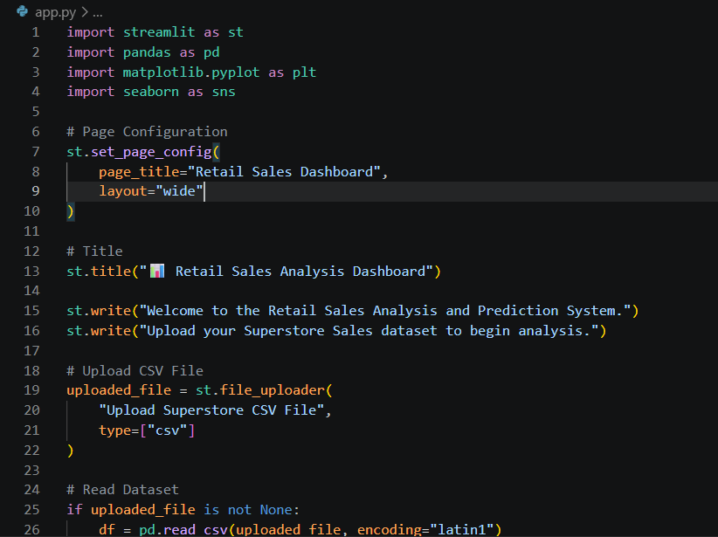

4.4 Dataset Upload Module

A file uploader component is provided using Streamlit. The user can upload the Superstore dataset in CSV format. After successful upload, the dataset is loaded into a Pandas DataFrame for further processing.
This makes the dashboard dynamic, allowing users to analyze different datasets without modifying the source code.

4.5 Dataset Preview

After uploading the dataset, the first few records are displayed in tabular format. This helps users verify that the correct dataset has been uploaded successfully.
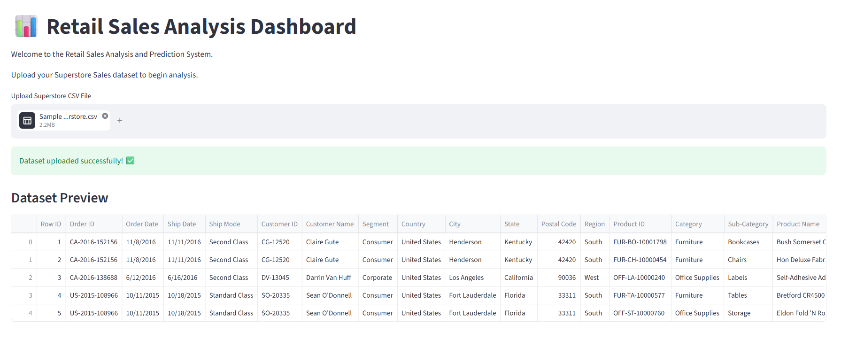

4.6 Dataset Summary

The dashboard computes and displays important summary statistics, including:

- Total number of records
- Total number of columns
- Average Sales
- Average Profit

These metrics provide a quick overview of the dataset before performing detailed analysis.

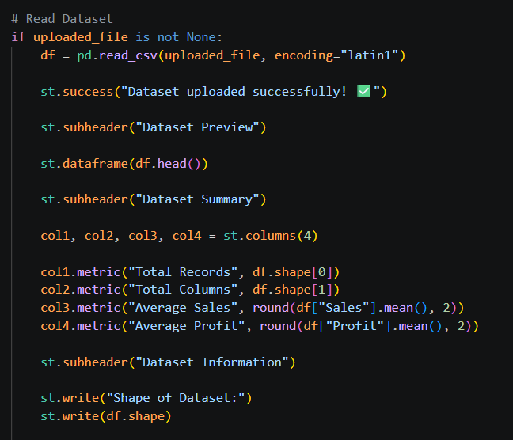

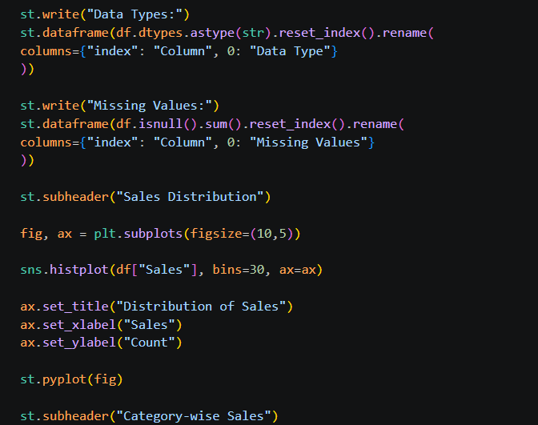

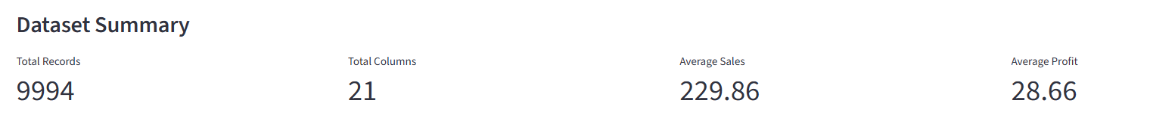

4.7 Data Inspection

The dashboard displays the data type of each column and checks for missing values. This step helps identify data quality issues before visualization and model building.

4.8 Sales Distribution Visualization

A histogram is generated using Seaborn and Matplotlib to visualize the distribution of sales values.

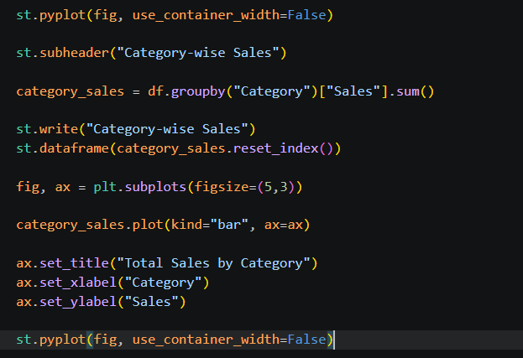

The graph provides insight into how sales are distributed across transactions and helps identify the presence of high-value or low-value sales records.

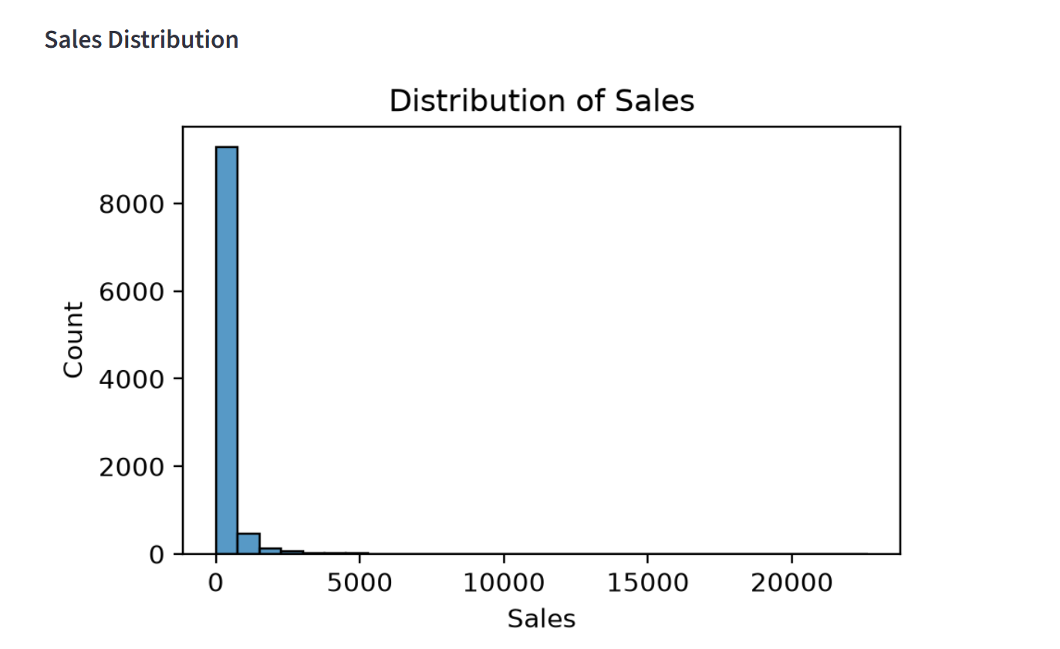
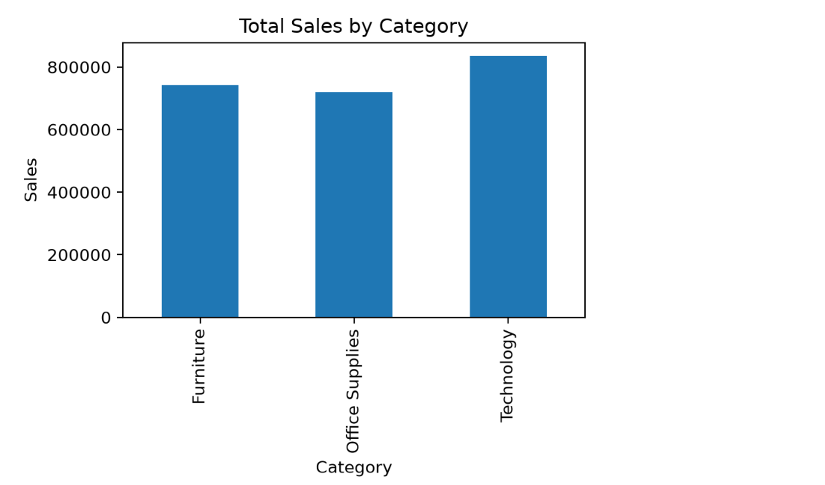
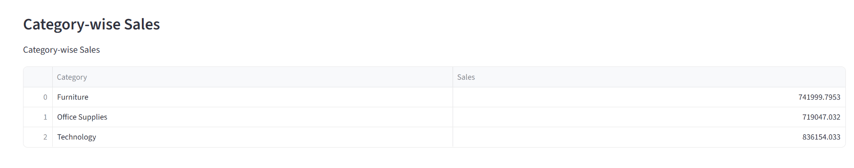

4.9 Profit by Category

The total profit generated by each product category is calculated using the groupby() function in Pandas. A bar chart is created using Matplotlib to compare the profitability of different product categories. This visualization helps identify which category contributes the highest overall profit.

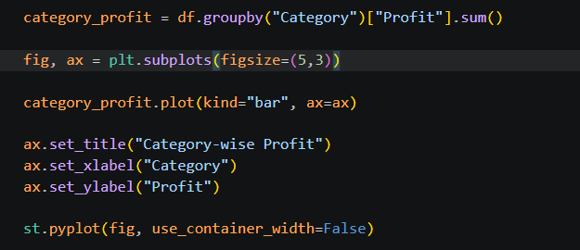

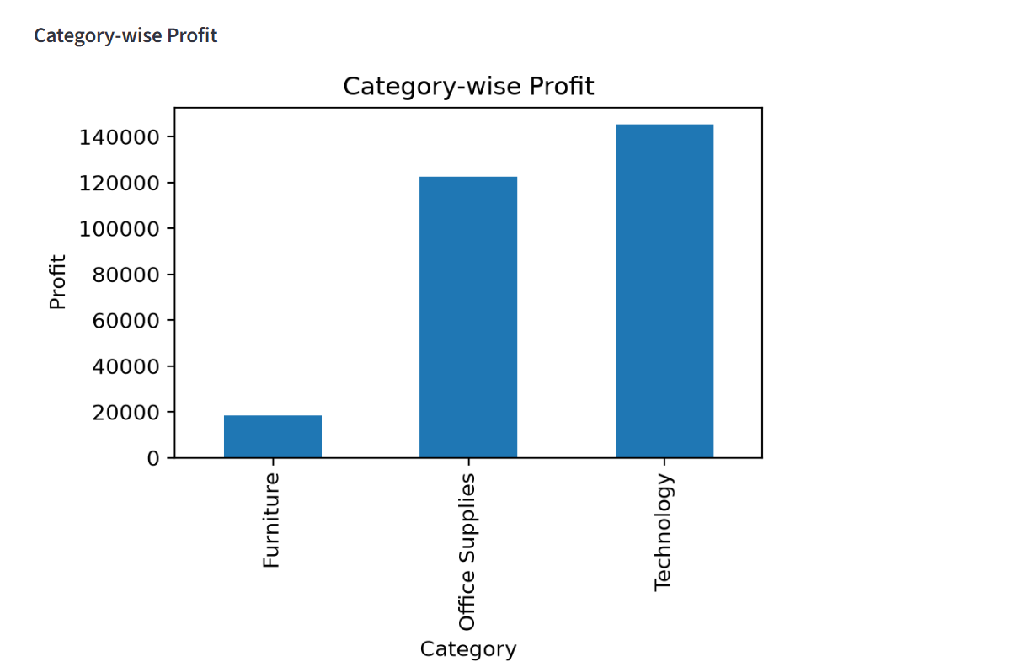

4.10 Sales by State

The dataset is grouped by state to calculate the total sales generated in each state. The top ten states with the highest sales are displayed using a bar chart. This visualization helps identify the best-performing geographical regions based on sales.

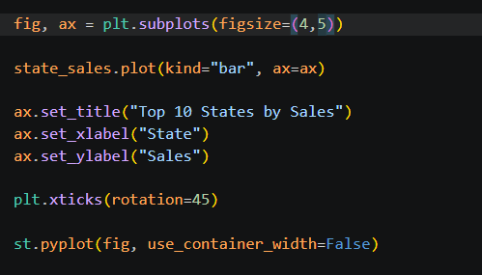
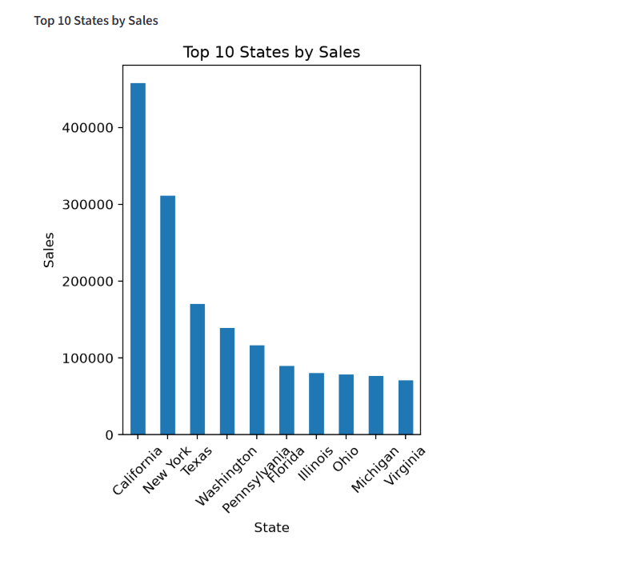
4.11 Monthly Sales Trend

The order date is converted into a date format using Pandas. The dataset is grouped by month to calculate total monthly sales. A line chart is generated using Matplotlib to visualize the sales trend over time. This graph helps identify seasonal patterns and changes in sales performance across different months.

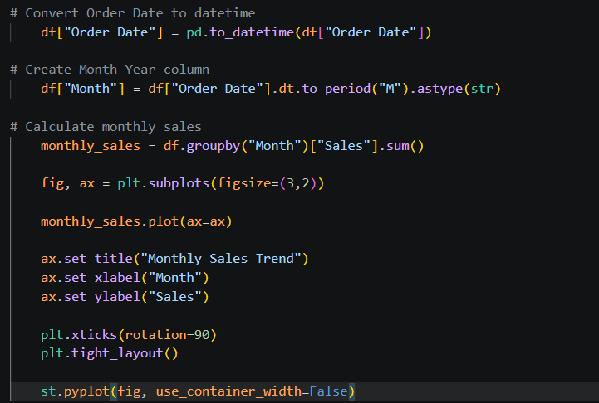
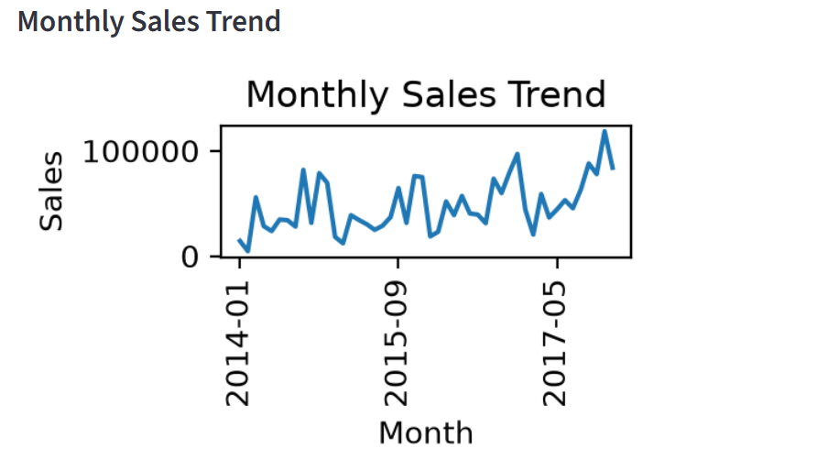

4.12 Correlation Heatmap

A correlation heatmap is generated using Seaborn to identify relationships between numerical variables in the dataset. Correlation values range from -1 to +1, where positive values indicate a direct relationship and negative values indicate an inverse relationship. This visualization helps understand how different variables influence each other.

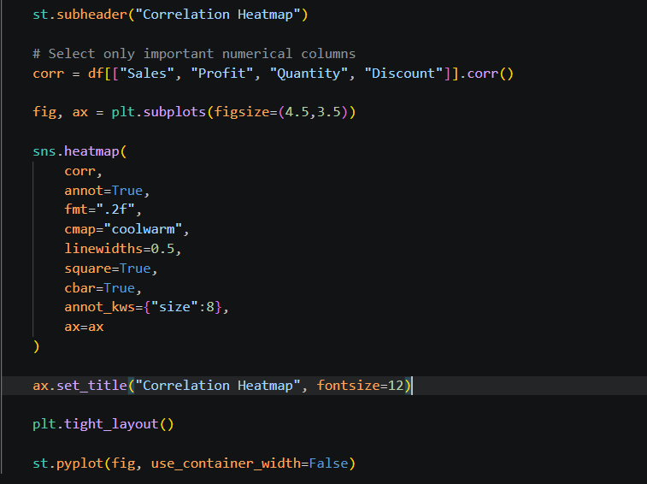
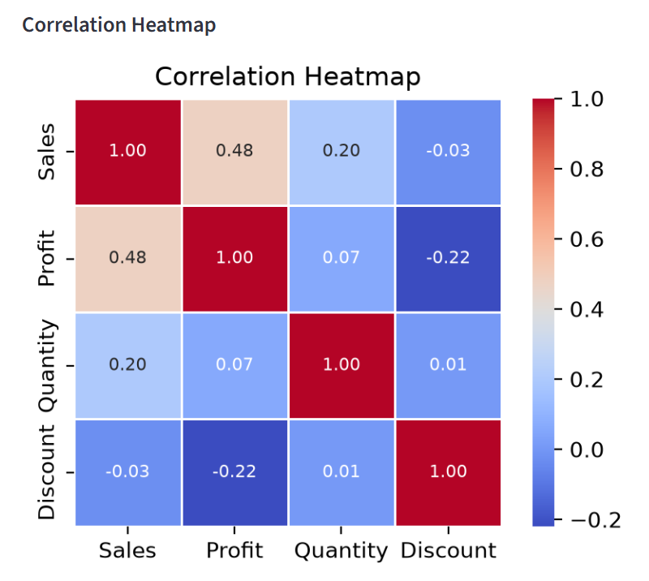

4.13 Linear Regression Model

A Linear Regression model is implemented using Scikit-learn to predict sales based on the Quantity and Discount attributes. The dataset is divided into training and testing sets using an 80:20 ratio. The model is then trained using the training dataset to learn the relationship between the selected input features and sales.

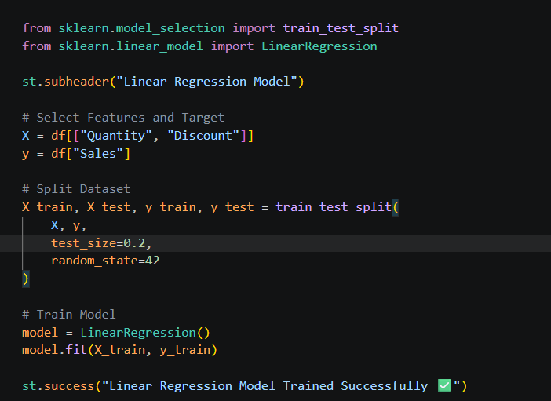

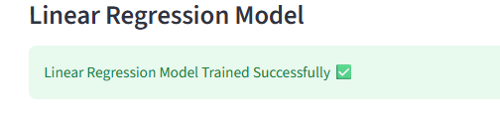

Chapter 5
- Testing, Validation & Results

5.1 Sales Prediction

The trained Linear Regression model is used to predict sales values for the testing dataset. The predicted sales values are compared with the actual sales values to evaluate the model's performance. The first ten predicted records are displayed for comparison.

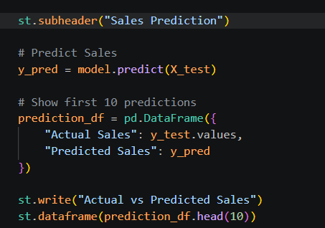

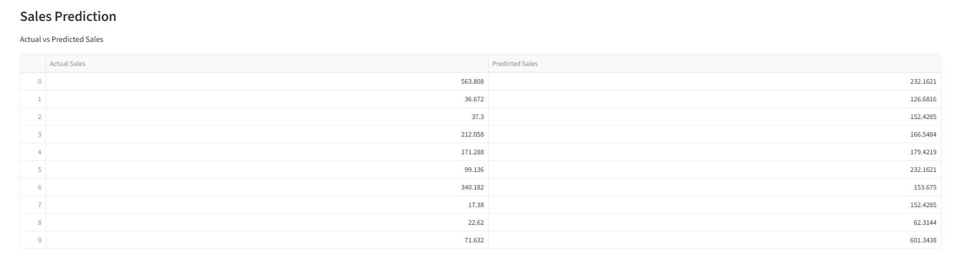

5.2 Model Accuracy

The performance of the Linear Regression model is evaluated using the R² (Coefficient of Determination) score. The R² score measures how well the independent variables explain the variation in the target variable. A higher R² value indicates better prediction accuracy.

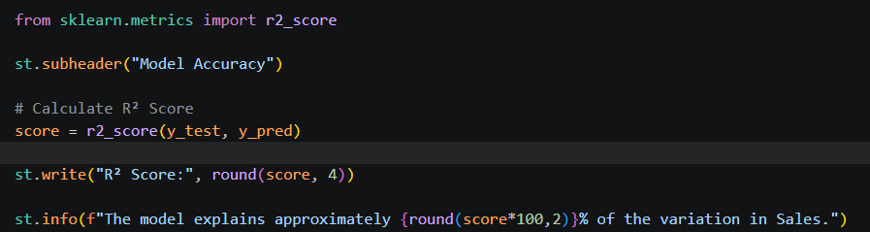
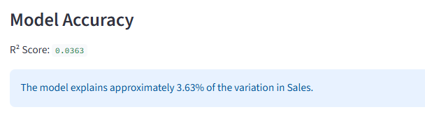
5.3 Actual vs Predicted Sales Visualization

A scatter plot is generated to compare the actual sales values with the predicted sales values produced by the Linear Regression model. The graph provides a visual representation of the model's prediction performance. Points closer to an ideal diagonal trend indicate better prediction accuracy.

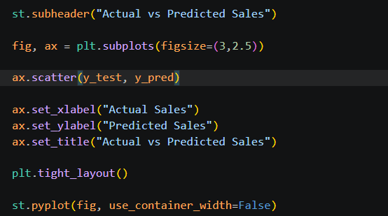
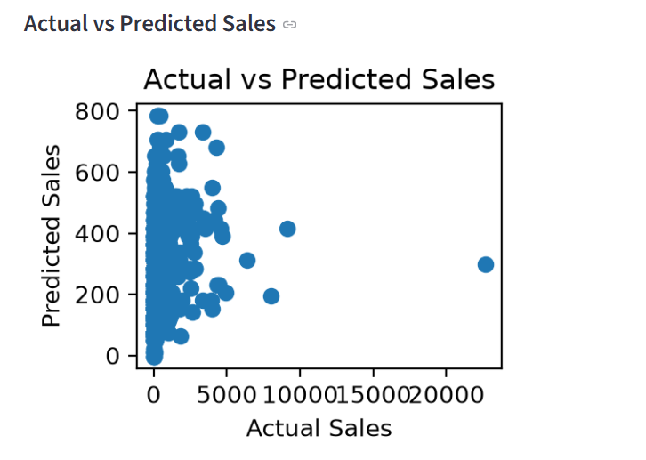
5.4 Key Insights
Based on exploratory data analysis and visualization, the dashboard presents the major business insights derived from the dataset. These insights help users quickly understand important sales patterns, profitability trends, and business performance.
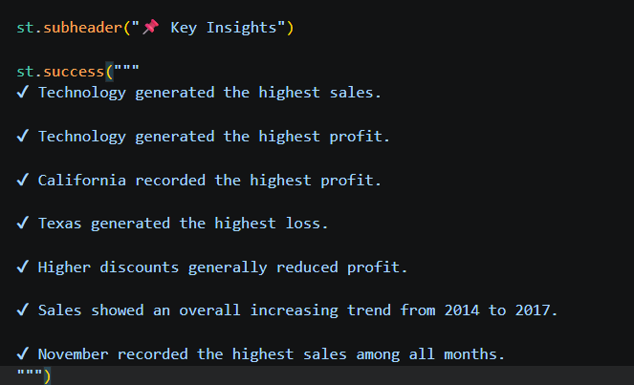
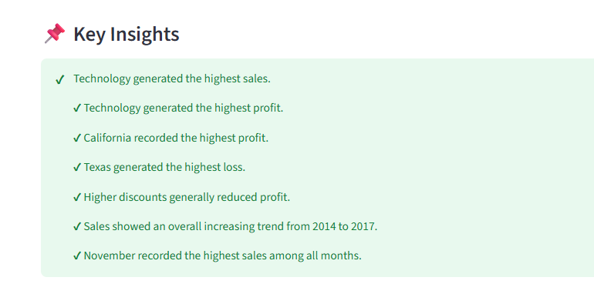
Chapter 6

Conclusion and Future Work
6.1 Conclusion
The Retail Store Sales Analysis and Sales Prediction Using Machine Learning project successfully analyzed the Superstore Sales Dataset using Python-based Data Science and Machine Learning techniques. The application was developed using Streamlit to provide an interactive web interface where users can upload a retail sales dataset and perform analysis.
The project involved data preprocessing, exploratory data analysis, visualization, and sales prediction using a Linear Regression model. Various business insights were generated, including category-wise sales, profit analysis, state-wise performance, monthly sales trends, and the impact of discounts on profitability. The analysis revealed that the Technology category generated the highest sales and profit, while Texas recorded the highest overall loss. Correlation analysis also showed that higher discounts negatively affected profit.
A Linear Regression model was developed using Quantity and Discount as input features to predict sales. The model achieved an R² score of 0.0363, indicating that additional business variables are required to improve prediction accuracy. Overall, the project demonstrates how Data Science, Machine Learning, and interactive dashboard development can be combined to support retail business decision-making.
6.2 Limitations
The application uses the Superstore Sales Dataset for analysis.
Sales prediction is performed using only Quantity and Discount as input features.
The Linear Regression model achieved limited prediction accuracy due to the small number of input variables.
The application analyzes uploaded datasets but does not connect to a live database.

6.3 Future Work
The project can be enhanced in several ways:
- Include additional features such as Customer Segment, Region, Category, Ship Mode, and Product information for improved prediction accuracy.
- Implement advanced machine learning algorithms such as Random Forest, Decision Tree, XGBoost, or Gradient Boosting.
- Add interactive dashboard filters and downloadable reports.
- Integrate the application with cloud databases or live retail data sources.
- Implement time-series forecasting to predict future sales trends.
The developed application demonstrates how Python, Data Science, Machine Learning, and Streamlit can be integrated to build an interactive retail analytics system that assists users in understanding sales performance and supporting business decision-making.

Chapter 7

References
[1] W. McKinney, Python for Data Analysis, 3rd ed. Sebastopol, CA, USA: O'Reilly Media, 2022.
[2] A. Géron, Hands-On Machine Learning with Scikit-Learn, Keras, and TensorFlow, 3rd ed. Sebastopol, CA, USA: O'Reilly Media, 2022.
[3] Python Software Foundation, "Python Programming Language." [Online]. Available: https://www.python.org
[4] Pandas Development Team, "Pandas Documentation." [Online]. Available: https://pandas.pydata.org
[5] NumPy Developers, "NumPy Documentation." [Online]. Available: https://numpy.org
[6] Matplotlib Development Team, "Matplotlib Documentation." [Online]. Available: https://matplotlib.org
[7] M. L. Waskom, "Seaborn Documentation." [Online]. Available: https://seaborn.pydata.org
[8] Scikit-Learn Developers, "Scikit-Learn Documentation." [Online]. Available: https://scikit-learn.org
[9] Streamlit Inc., "Streamlit Documentation." [Online]. Available: https://streamlit.io
[10] Tableau, "Sample Superstore Dataset." [Online]. Available: https://community.tableau.com

Chapter 8

Appendix (Optional)

  - GitHub Repository
The complete project, including Jupyter Notebook, dataset analysis, and outputs, is available at:
Github link: https://github.com/divyabkrishna2022-spec/Retail-Sales-Analysis

8.2 Project Execution
The project was developed using Visual Studio Code and Jupyter Notebook. Jupyter Notebook was used for data exploration and testing, while the final application was developed as a Streamlit web application.
8.3 Tools Used
- Visual Studio Code
- Jupyter Notebook
- Python
- Libraries: Pandas, NumPy, Matplotlib, Seaborn, Scikit-learn, Streamlit
8.4 Steps to Run the Project
- Open Command Prompt (CMD).
- Navigate to the project folder. (Eg: cd C:\Users\divya\RetailSalesDashboard)
- Run the following command: streamlit run app.py

Date : 01/07/2026
Student Name and Signature : Divya B Krishna

Name and Signature of the Evaluator.

Date

